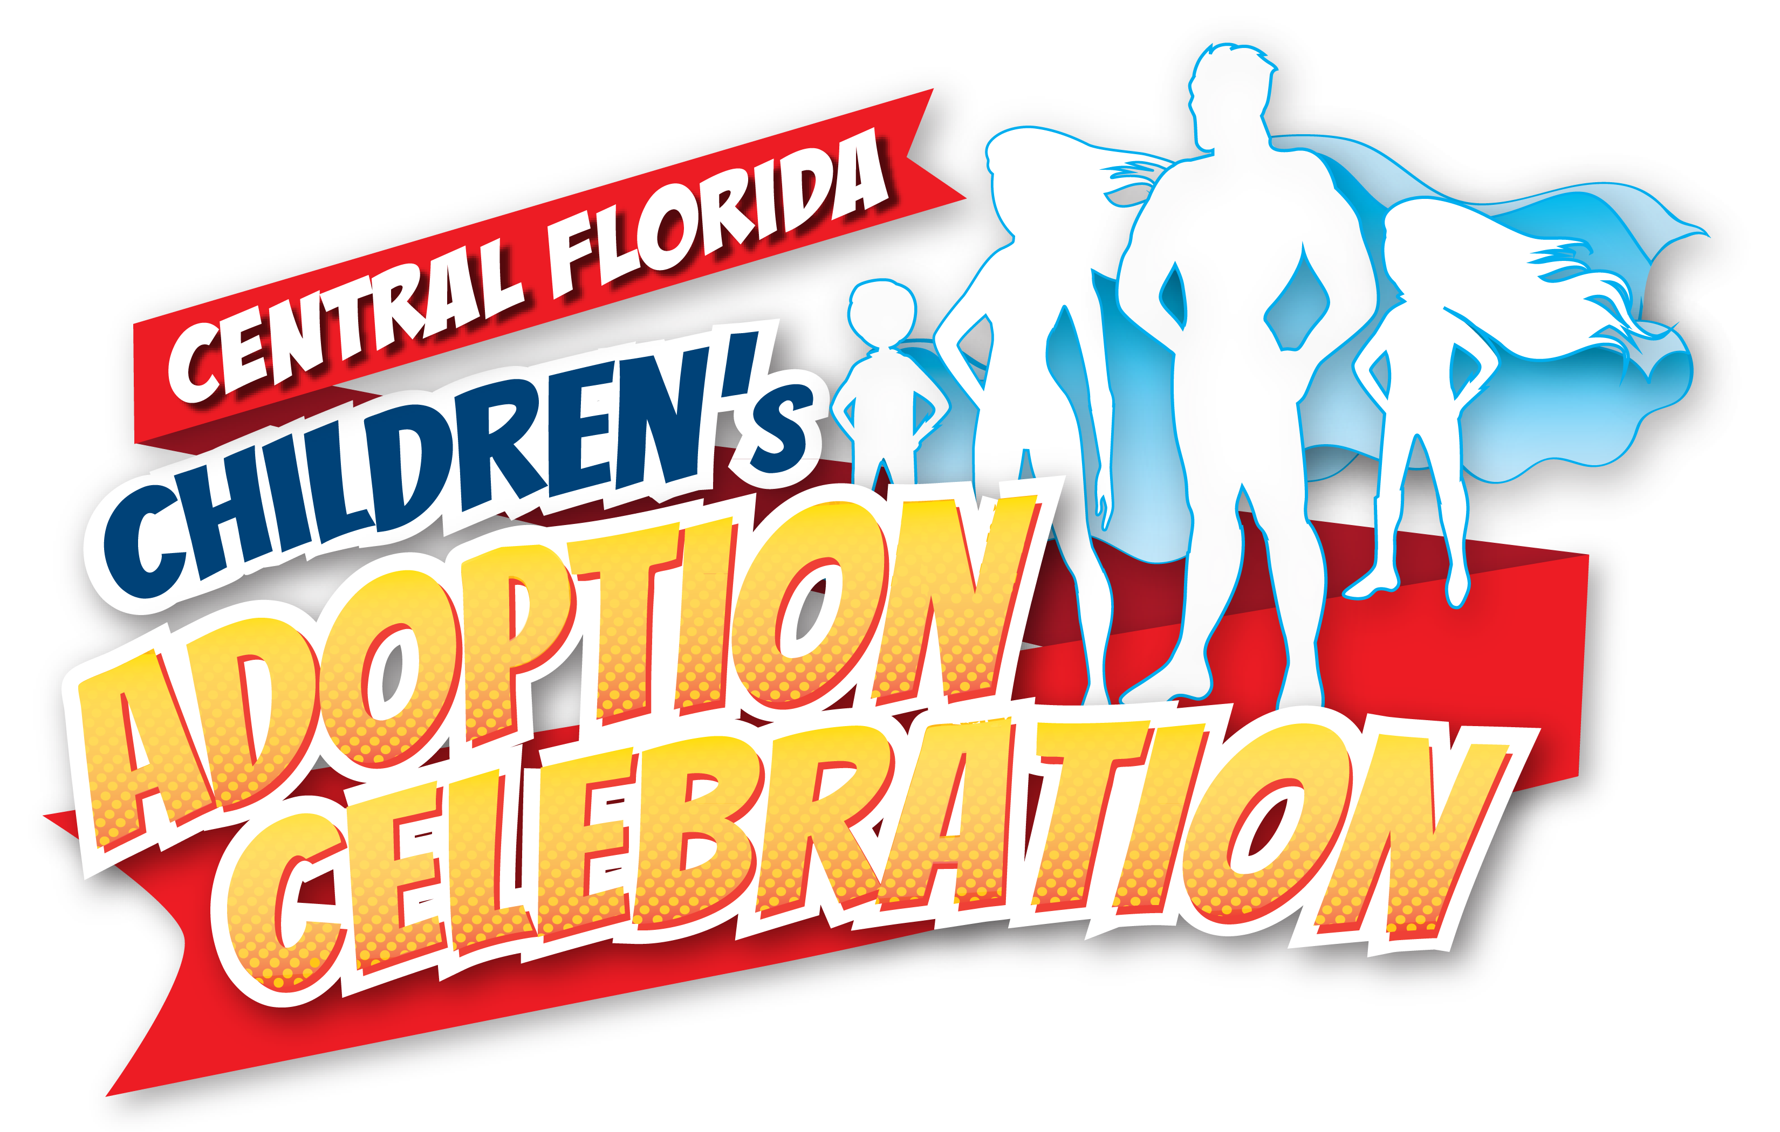

Central Florida’s National Children’s Adoption Celebration

On Sunday, November 20, 2022, Central Florida will host its 3rd Annual National Children’s Adoption Celebration. It is a fantastic opportunity to bring local families and prominent businesses together in our community at beautiful Blue Jacket Park, for an afternoon of fun, games, food and celebration to acknowledge all the superhero adoptive families in Central Florida. Your participation in the event will benefit the celebration of adoptive families.

Our festivities will be highlighted by food trucks, a climbing wall, carnival games, bungee jumps, a bounce house and slide, adult beverages and a special live performance by the popular mambo rock band, Rico Monaco.

After years of struggling to conceive, and finally being blessed with her family through adoption, Deirdre Klein Ochipinti, founder and host of The Annual Children’s Adoption Carnival, has made it her mission to create awareness of the gift of adoption, while honoring adoptive parents and children, as they are truly real-life superheroes. Thank you for your sponsorship in helping families wanting to adopt.

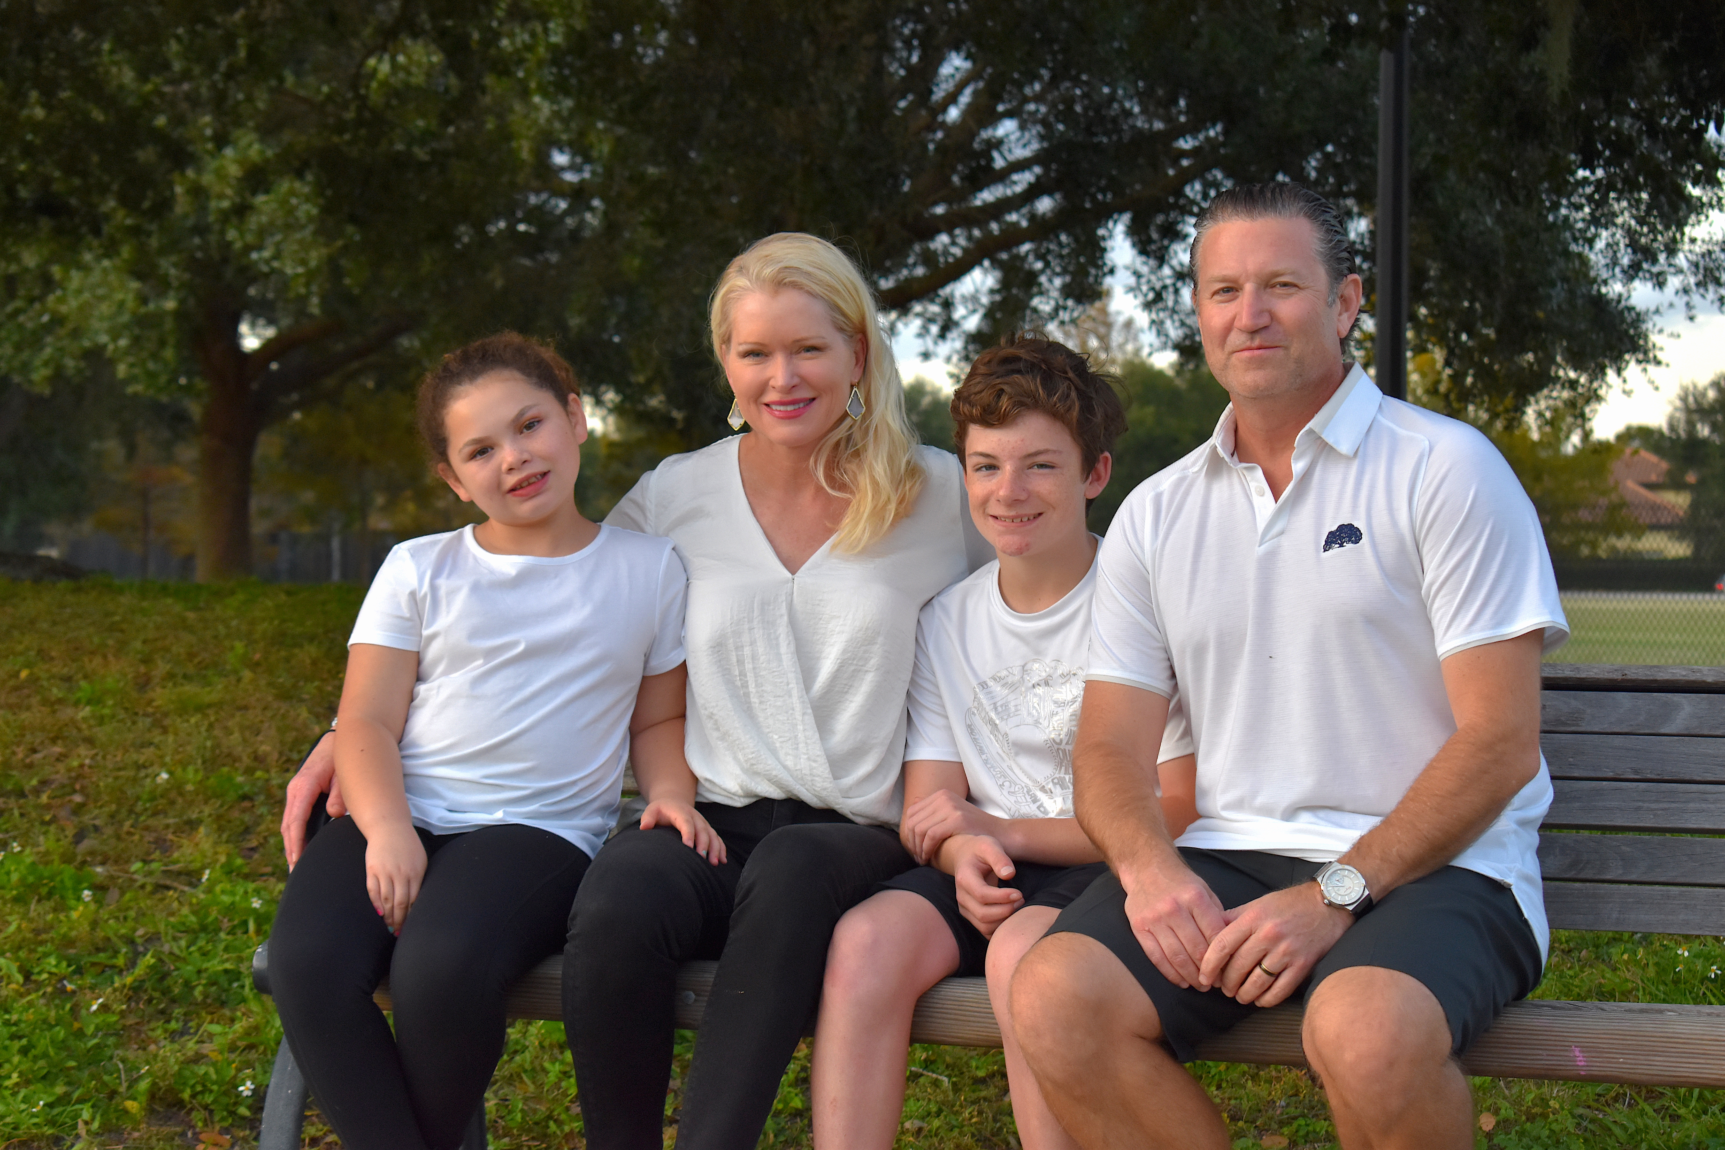

SPONSORSHIP OPPORTUNITIES
Superhero Sponsor (limited to four)

Pre-Event Promotional Opportunities
Recognizing your company as a Superhero Sponsor by prominently placing your company’s logo on the following:

- Website – Logo recognition on the official event website, recognizing your company as a Sponsor, to include a hyperlink to your company website

- Media and Advertising – Prominent recognition on all event media and advertising

- Other Promotional Materials
- Company name listed on event invitations and other promotional materials
- Logo recognition on the event flyer and Facebook page

Event Promotional Opportunities
- Company Yard Signs at Event
- Event Signage
- Verbal recognition from the podium
- Company tent
- Opportunity to hand out company materials
- Total Investment: $1,500
Hero Sponsor

Pre-Event Promotional Opportunities
- Website – Logo recognition on the official event website, recognizing your company as a Sponsor, to include a hyperlink to your company website
- Logo recognition on the event flyer and Facebook page

Event Promotional Opportunities
- Logo on Event Signage
- Verbal recognition from the podium
- Opportunity to hand out company materials
- Total Investment:$750
Cape Sponsor

Pre-Event Promotional Opportunities
- Website – Logo recognition on the official event website, recognizing your company as a Sponsor, to include a hyperlink to your company website

Event Promotional Opportunities
- Verbal recognition from the podium
- Total Investment: $500

SPONSORSHIP COMMITMENT
Please check one:
q Superhero – $1,500.00
q Hero – $750.00
q Cape – $500.00

Name of Corporation or Family:
Main Contact Name:
Address:
Email:
Website (if applicable):
Phone Number:

I/We commit to the above-selected sponsorship category for the 3rd Annual Central Florida National Children’s Adoption Month Celebration

Signature:

____________________________________________________ Date:_______________________

Please check one:
Email logo artwork in q ai q eps q pdf q png q jpg to: dianemvivian@gmail.com
Please make checks payable to: Children’s Adoption Celebration, Inc.
or visit our website to make a credit card payment through RallyUp. http://www.ChildrensAdoptionCelebration.com

